CHARUSAT UNIVERSITY OF SCIENCE AND TECHNOLOGY (CHARUSAT), CHANGA – 388 421

CHARUSAT STARTUP AND INNOVATION CENTRE (CSIC)

Brochure

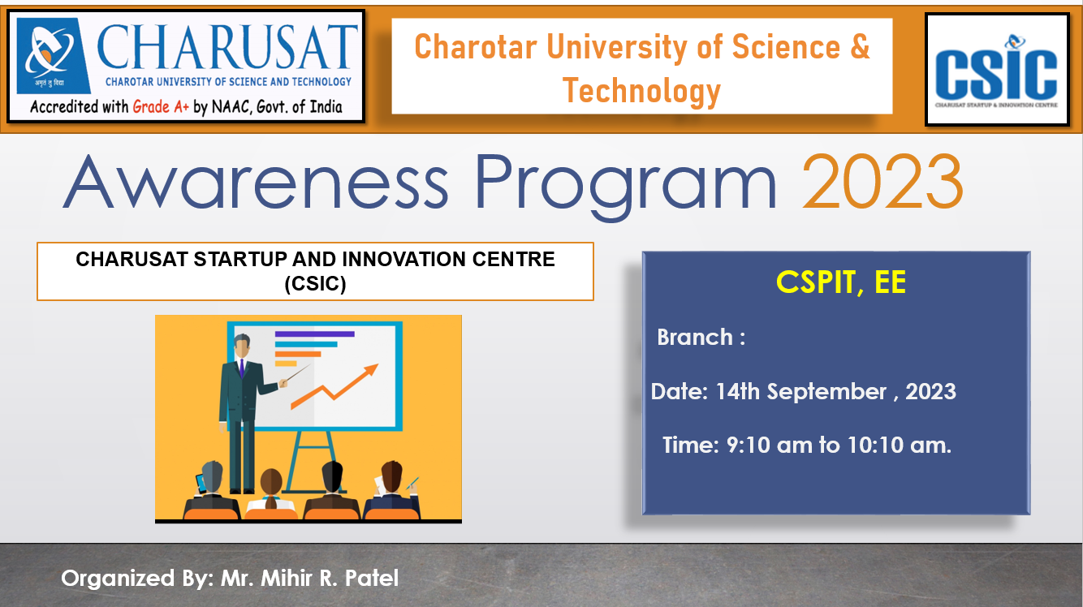

Event Report

Name of Department : M&V Patel Department of Electrical Engineering
Name of Event : Awareness session on "CHARUSAT Startup and Innovation Centre (CSIC)"
Date and Time of Event : 14th September, Thursday, 2023, 09:10 To 10:10 a.m.
Event coordinator : Mihir R Patel (Assistant professor Electrical Dept.)
: Jignesh S Patel (Assistant professor Electrical Dept.)
Resource person details:
Sr. No. | Name of the resource person | Organization of resource person
1. | Mihir R. Patel | CSPIT, EE

Event Schedule:
Date | Time | Activity
14th September , 2023 | 09:10 To 10:10 a.m. | Awareness Program

Summary of the Event:
As a part of CSIC we have arrange an Awareness Program on “CHARUSAT Startup and Innovation Centre(CSIC)”, on 14th September, 2023. Mr. Mihir R. Patel, speaker has conducted this session during 09:10 To 10:10 a.m.
The awareness session was a resounding success, providing valuable insights into the dynamic ecosystem fostering innovation and entrepreneurship. The session highlighted CSIC's pivotal role in nurturing budding entrepreneurs, offering state-of-the-art facilities, mentorship, and funding opportunities. Participants gained a comprehensive understanding of the incubation process, access to industry networks, and support for intellectual property rights. Prominent entrepreneurs and industry experts shared their experiences, inspiring the attendees towards innovative pursuits. The event culminated in an interactive Q&A session, solidifying participants' commitment to leveraging CSIC's resources for transformative ventures.
I am very thankful to department head Dr. Nilay Patel sir, CSIC coordinator Dr. Jaimin N Undavia sir, and student coordinators for their supports for making this event successful.

Registration fee (if any): No registration fees
Attendance List and No. of Participants: 35
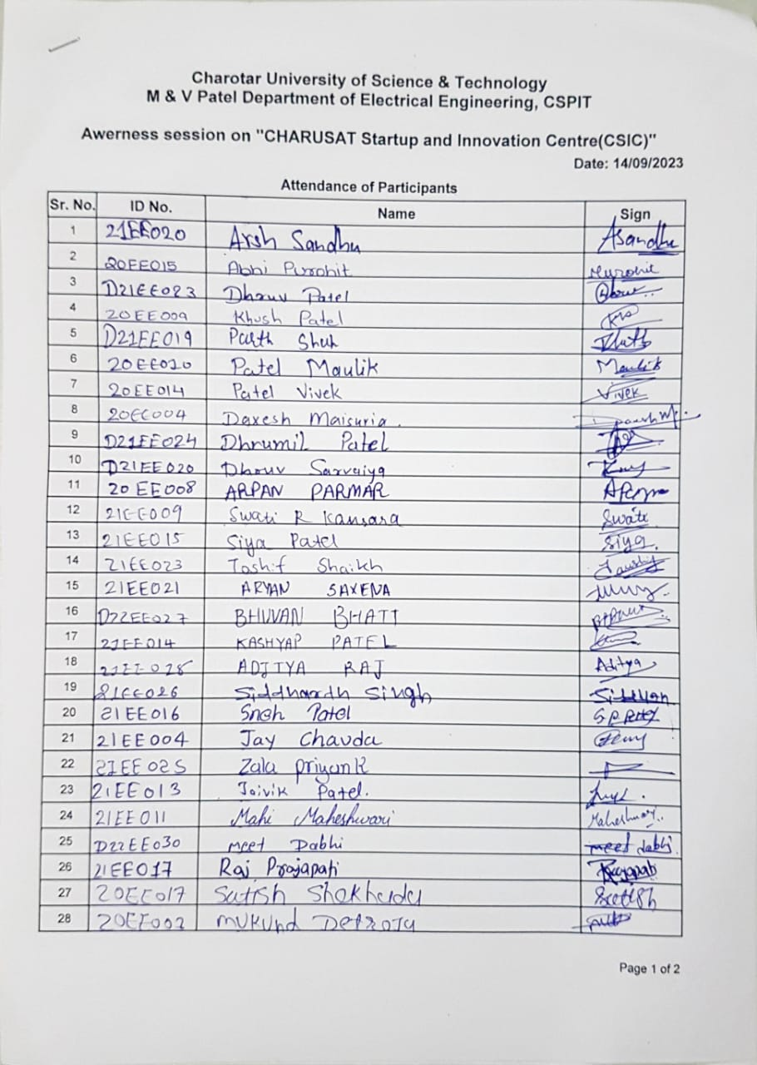
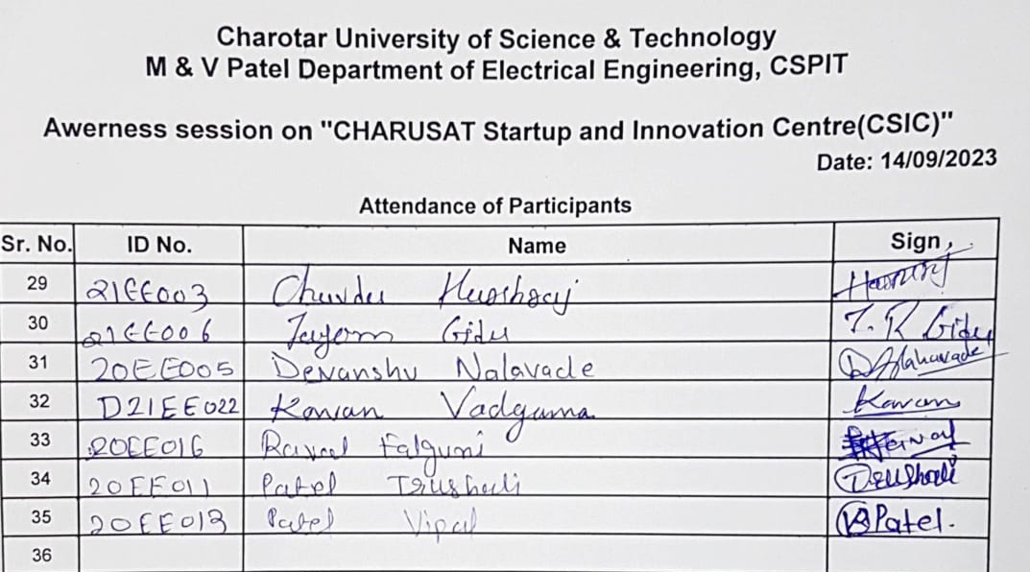
Accounts details: NA

Overall impact of seminar: Excellent
Photographs of the event with captions:

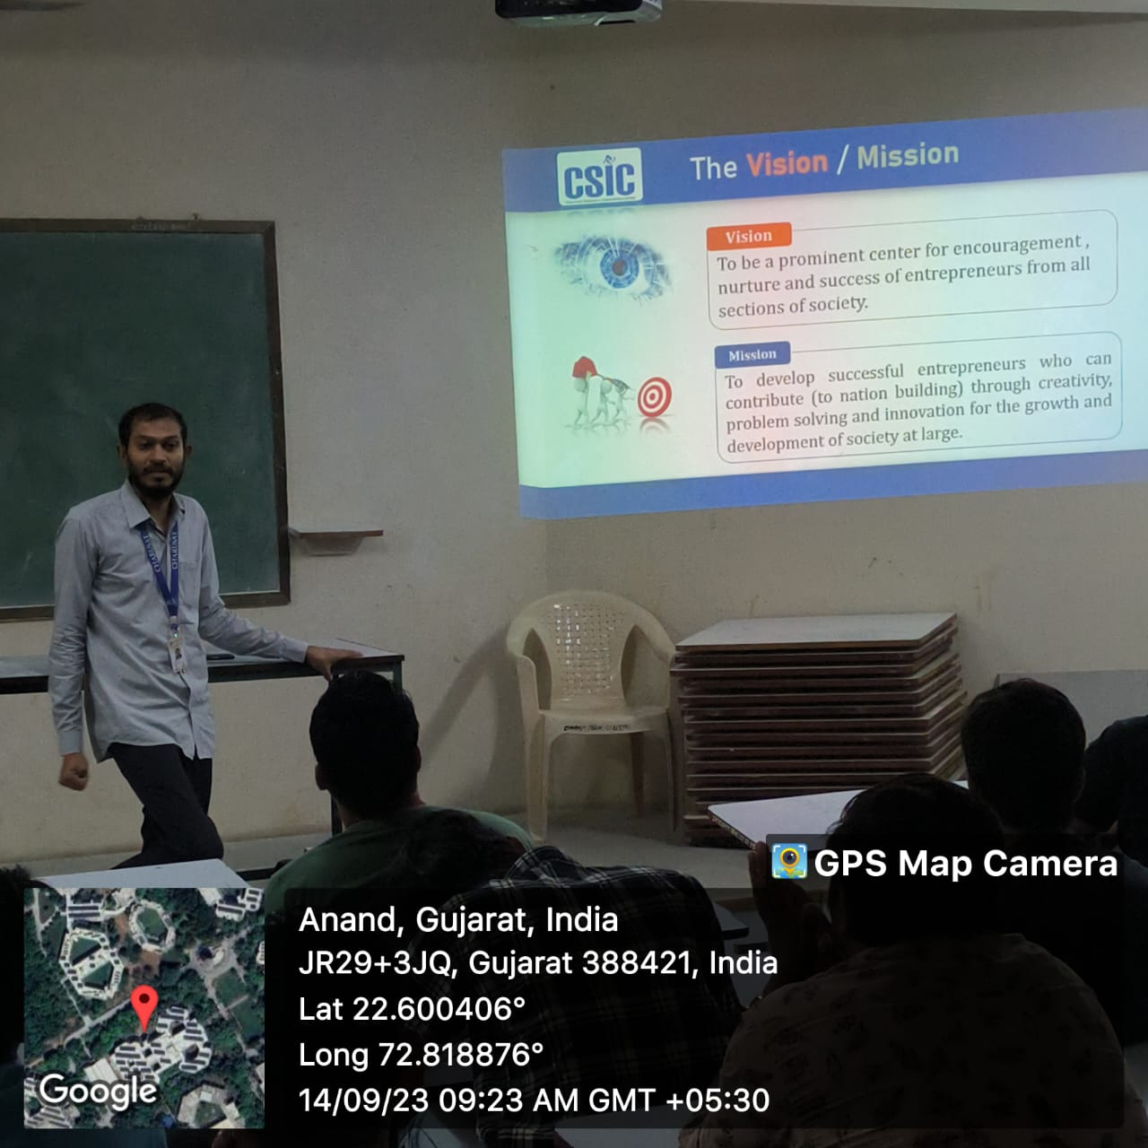

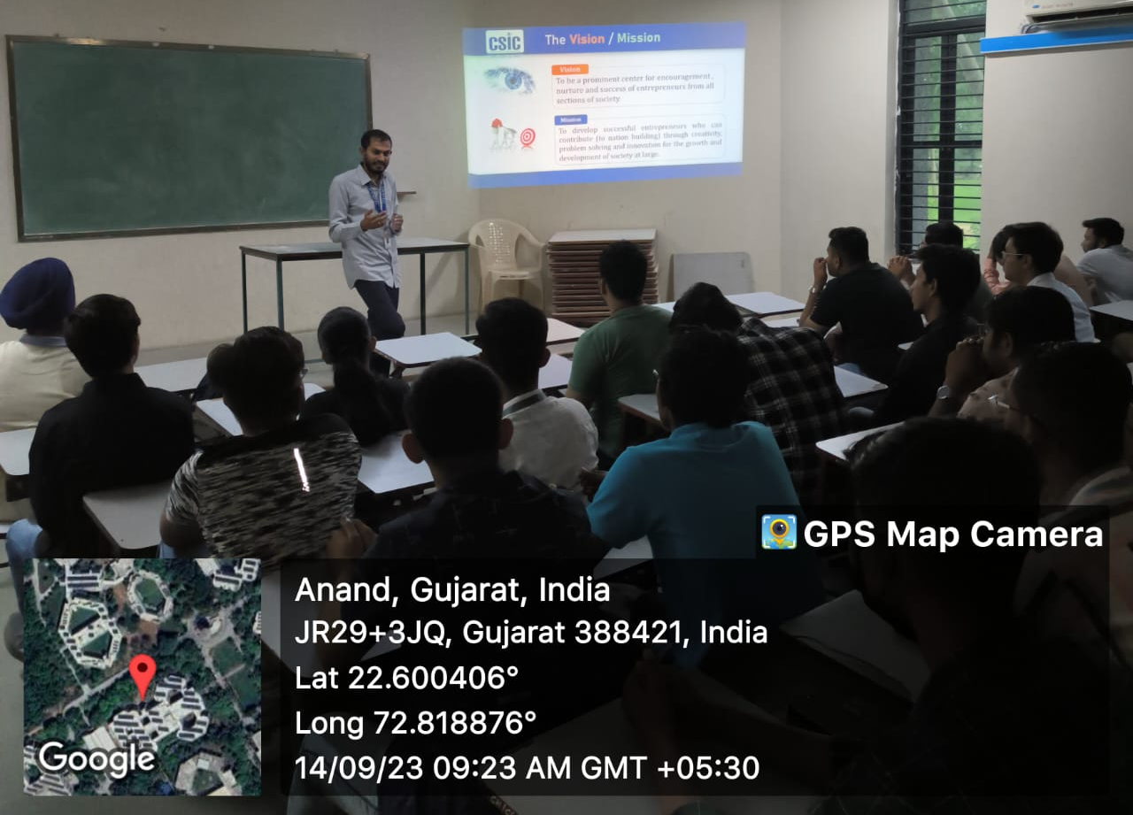

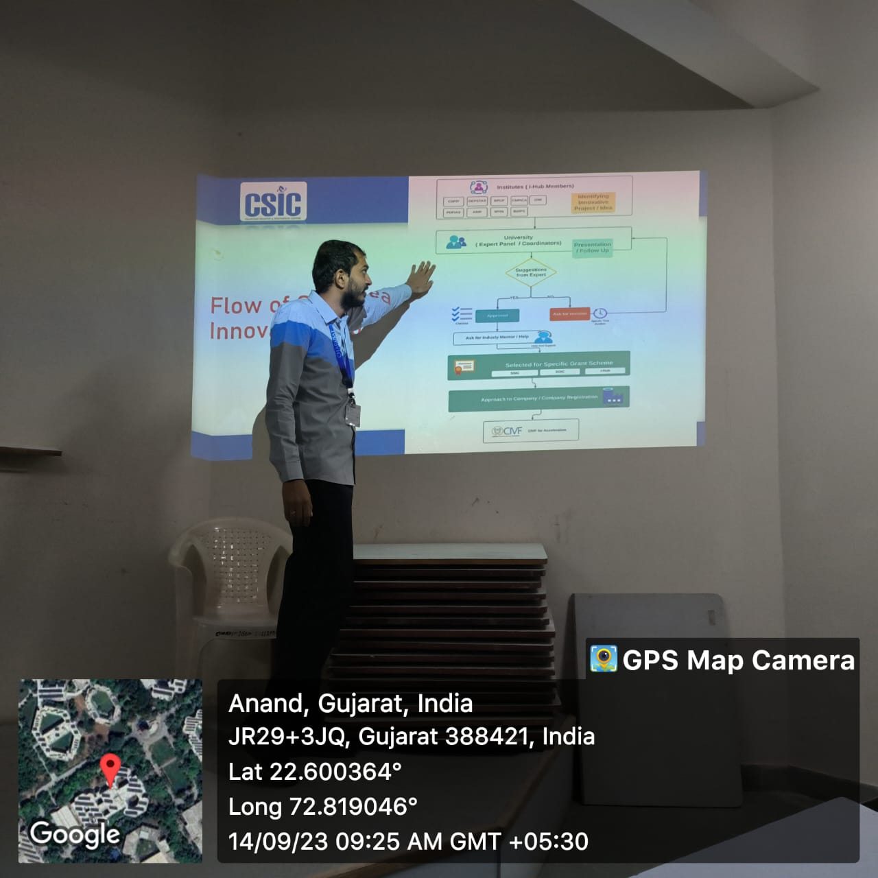

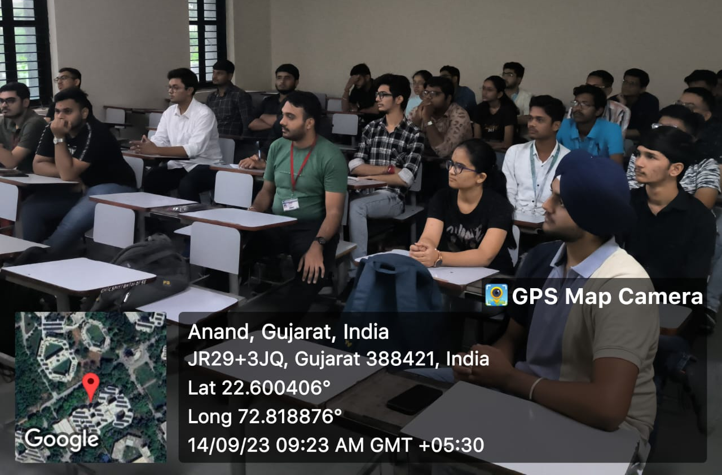

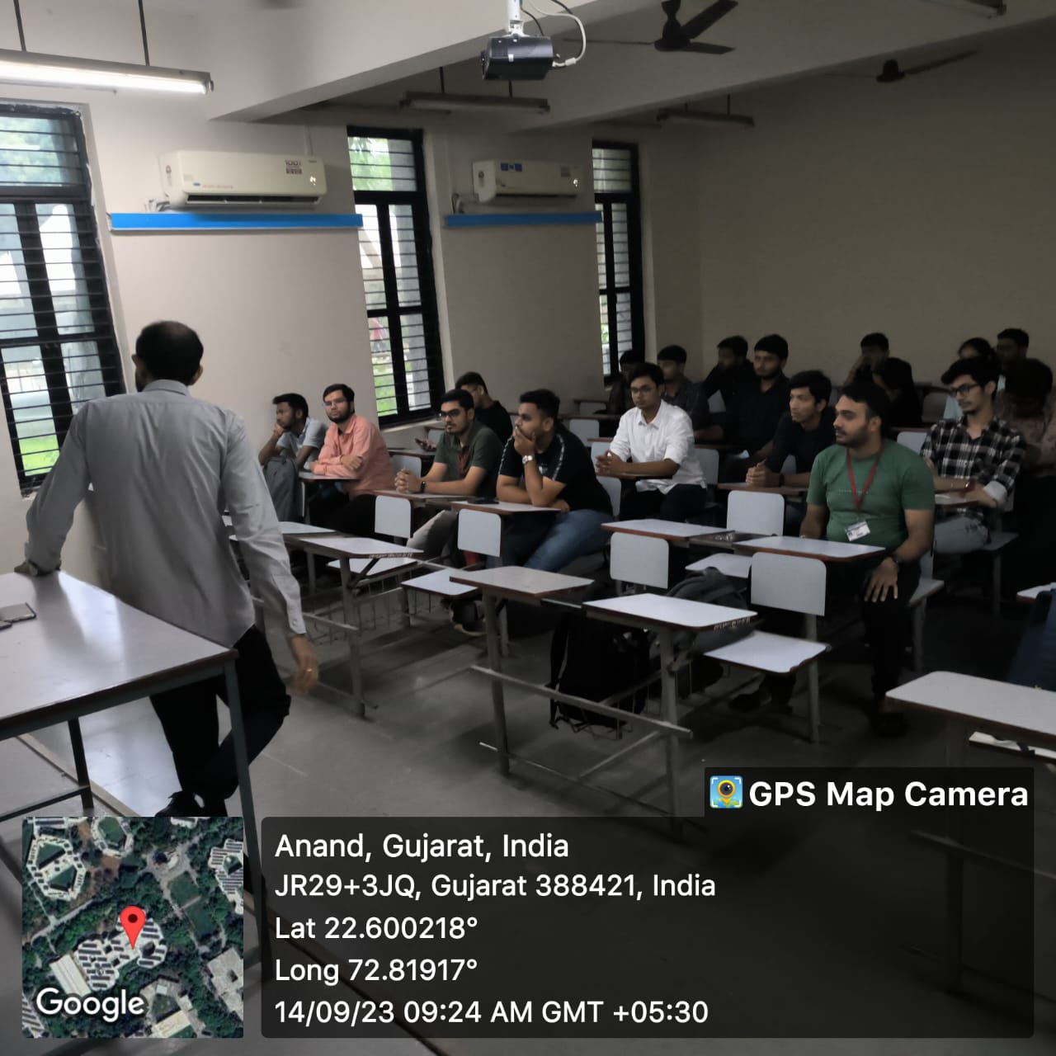

Department Coordinator:
Mihir R Patel
Assistant Professor,
M&V Patel Department of Electrical Engineering
C.S. Patel Institute of Technology.

To
Dr. Jaimin N Undavia
Coordinator
CSIC
CHARUSAT, Changa

